_ANSWERS_________________________

MID-TERM EXAM - FISH STOCK ASSESSMENT - ASMFC 2005 WORKSHOP

Question 1: Growth and maturity models

Given the following length and weight at age data for scup (Hamer 1970), estimate the parameters for the Von Bertalanffy growth function for length, and the coefficients (a & b) of the Weight-Length relationship. O’Brien et al. (1993) at the NEFSC investigated the maturation of scup and 19 other northeast fishes, and provide the following data on proportion mature as a function of length. Estimate the parameters of a logistic maturity function that can be used to characterize this data. Interpret the results of these analyses.
Hamer (1970) |  |  |  | O'Brien et al. (1993)
age | obs. length (cm) | obs. Weight (g) |  | length | maturity
0 | 4.1 | 46.8 |  | 10 | 0.00
1 | 10.6 | 60.2 |  | 11 | 0.05
2 | 17.6 | 183.7 |  | 12 | 0.08
3 | 21.5 | 278.7 |  | 13 | 0.10
4 | 25.4 | 368.7 |  | 14 | 0.20
5 | 26.7 | 425.9 |  | 15 | 0.39
6 | 28.2 | 490.3 |  | 16 | 0.60
7 | 30.1 | 589.9 |  | 17 | 0.78
8 | 31.8 | 683.2 |  | 18 | 0.90
9 | 33.4 | 780.8 |  | 19 | 0.95
10 | 34.6 | 861.5 |  | 20 | 0.99
11 | 35.5 | 920.9
12 | 36.3 | 980.7
13 | 36.7 | 1005.8

Answer:
Estimated Parameters for the VonBertalanffy Growth and Length-Weight Models
Solver Values for Model Parameters
 | Before Solver | After Solver
a | 0.67 | 0.29
b | 3.00 | 2.25
K | 0.20 | 0.22
L∞ | 40.00 | 38.10
t₀ | 0.50 | -0.56
Estimated Parameters for the Maturity Model

Solver Values of Model Parameters
alpha | 0.853697
L50mat | 15.52202

Plot of VonBertalanffy Model and Data

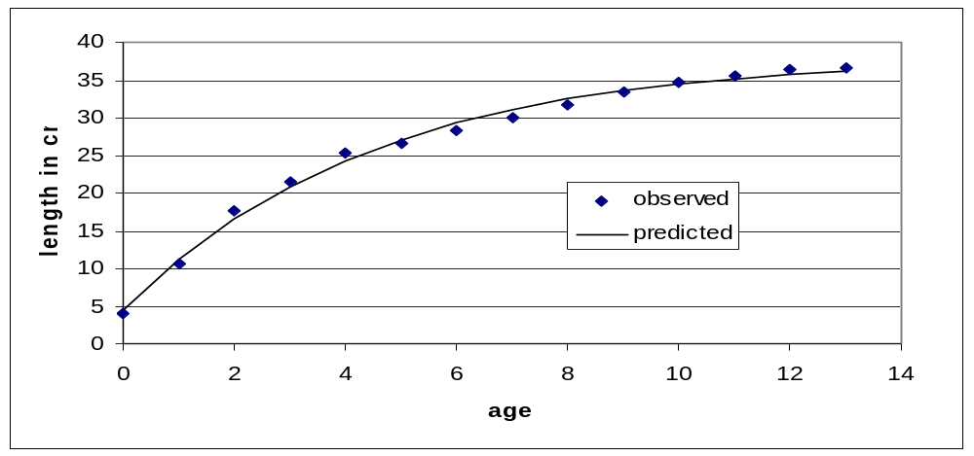

Plot of Length-Weight Model and Data

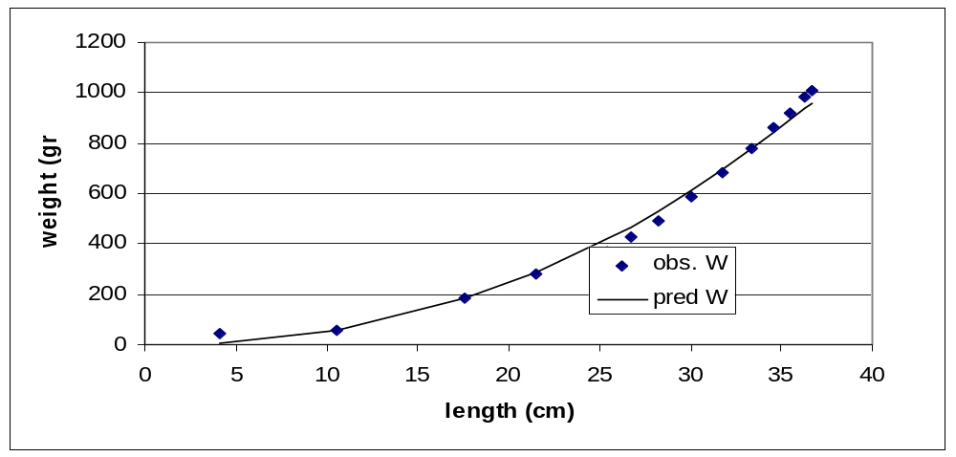

Question 2. Estimating Mortality

The longevity of scup is 15 years. Estimate the instantaneous natural mortality rate for scup.
Using the following mean catch per tow data from a fall state trawl survey, estimate the total mortality for the 1985 and 1995 year classes of scup in the post-recruitment period. What was the fishing mortality on the 1985 and 1995 year classes of scup. Note that in the early 1990s, management restricted landings of scup with trip quotas.

year class | age | 0 | 1 | 2 | 3 | 4 | 5 | 6
1985 | cpue | 12.33 | 10.00 | 3.26 | 0.97 | 0.33 | 0.13 | 0.04
1995 | cpue | 141.88 | 129.36 | 68.90 | 35.61 | 16.16 | 9.61 | 4.19
Answer:
NATURAL MORTALITY
m=3/15=0.2
1985 year class |  | F=Z-M | 1.1-0.2 = 0.9
1995 year class |  | F=Z-M | 0.68-.0.2 = 0.48

Plot of Catch Curves:

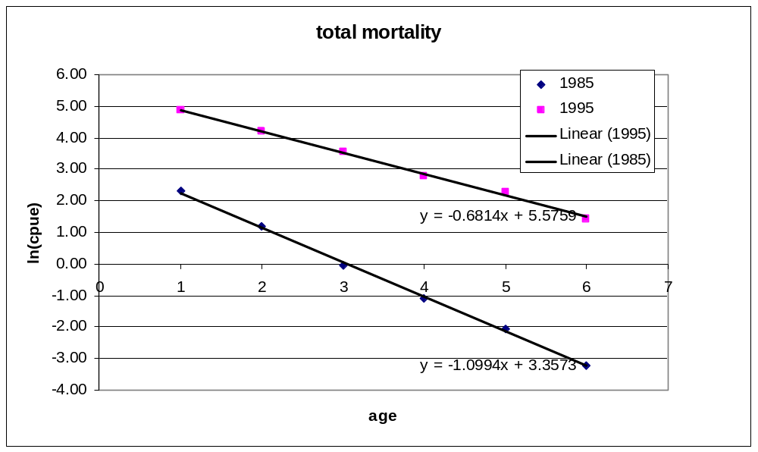

Question 3. Trawl codend selectivity

Given the results of a bottom trawl codend selection experiment, expressed as the probability of retention as a function of fish length for 12 cm stretched mesh, 4 mm double twine, (DeAlteris and Reifsteck, 1992), determine the L₅₀s and steepness of the selection curves for these codends. From this analysis, estimate a mean selection factor and steepness representative of both codends, and then estimate the selection characteristics of a 16 cm codend. Discuss the differences in the selection characteristics on square and diamond mesh codends and in 12 and 16 cm codends.
Fish length | Square Mesh | Diamond mesh
cm | probability | probability
10 | 0.00 | 0.00
11 | 0.00 | 0.00
12 | 0.00 | 0.00
13 | 0.00 | 0.00
14 | 0.00 | 0.00
15 | 0.01 | 0.00
16 | 0.02 | 0.01
17 | 0.05 | 0.06
18 | 0.09 | 0.10
19 | 0.15 | 0.22
20 | 0.25 | 0.30
21 | 0.47 | 0.51
22 | 0.60 | 0.70
23 | 0.78 | 0.80
24 | 0.91 | 0.89
25 | 0.95 | 0.93
26 | 0.97 | 0.96
27 | 0.98 | 0.98
28 | 1.00 | 1.00
29 | 1.00 | 1.00
Answer:
Square Mesh | L50 sel | 21.3056
12 cm | alpha | 0.757122

Diamond Mesh | L50sel | 20.98144
12 cm | aplha | 0.714308

12 cm
mean L50 |  | 21.15
mean alpha |  | 0.74
SF=L50/ml |  | 1.7625
Mesh | L50 |  | 28.2
16 cm | alpha |  | 0.74

Plot of Selection Curves:
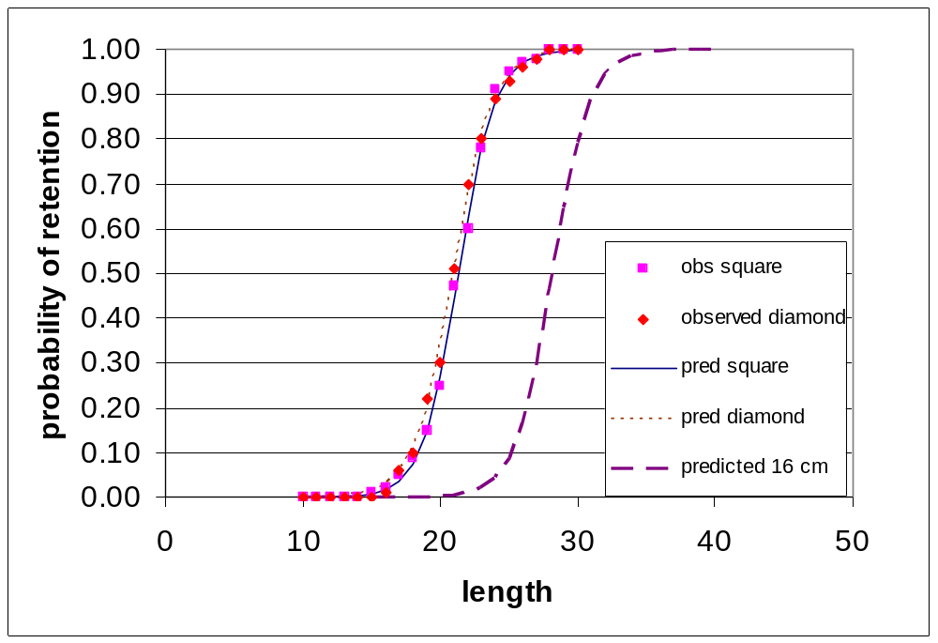

Question 4. YPR and SSBPR

Based on the biological characteristics (V-B growth coefficient, L-W relationship, and the maturity function) for scup in the mid-Atlantic, and the selectivity characteristics of 12 and 16 cm codends, that control recruitment to the trawl fishery: determine the yield and spawning biomass per recruit for this species for the following fishery mortality rates: 0.00, 0.1, 0.2, 0.3, 0.4, 0.5, 0.75, 1.00, 1.25, 1.50, 1.75, and 2.00 for both 12 and 16 cm codends. Estimate the following reference points: F_{max} and F_{0.1} for the YPR analysis, and F_{25%} limit so as to maintain 25% of the virgin SSB/R.

Answer:

mesh length |  | L50
12 cm |  | 21.2
F | YTrawl | SSBTrawl | %SSBPR | F0.1
0 | 0.0 | 1541.0 | 1.00 | 778.6334
0.1 | 77.9 | 1019.4 | 0.66 | 266.7682
0.2 | 104.5 | 759.1 | 0.49 | 106.7851
0.3 | 115.2 | 611.5 | 0.40 | 44.74548 | F0.1=0.25
0.4 | 119.7 | 518.8 | 0.34 | 17.46504
0.5 | 121.4 | 456.0 | 0.30 | 0.141946
0.75 | 121.5 | 363.1 | 0.24 | -6.7034
1 | 119.8 | 312.5 | 0.20 | -7.416 | Fmax=0.75
1.25 | 117.9 | 280.5 | 0.18 | -6.83722
1.5 | 116.2 | 258.4 | 0.17 | -6.04795 | F25%=0.70
1.75 | 114.7 | 242.1 | 0.16 | -5.3122
2 | 113.4 | 229.5 | 0.15 | 56.69801

mesh length |  | L50
16 cm |  | 28.2
F | YTrawl | SSBTrawl | %SSBPR | F0.1
0 | 0.0 | 1541.0 | 1.00 | 645.4856
0.1 | 64.5 | 1201.9 | 0.78 | 273.7894
0.2 | 91.9 | 1015.1 | 0.66 | 142.1594
0.3 | 106.1 | 900.8 | 0.58 | 83.45407
0.4 | 114.5 | 824.6 | 0.54 | 53.23691 | F0.1=0.37
0.5 | 119.8 | 770.2 | 0.50 | 28.67674
0.75 | 127.0 | 683.7 | 0.44 | 13.52342 | Fmax>2
1 | 130.4 | 631.9 | 0.41 | 7.365802
1.25 | 132.2 | 596.7 | 0.39 | 4.376612
1.5 | 133.3 | 570.7 | 0.37 | 2.743325 | F25%>2
1.75 | 134.0 | 550.4 | 0.36 | 1.772599
2 | 134.4 | 534.0 | 0.35 | 67.21358

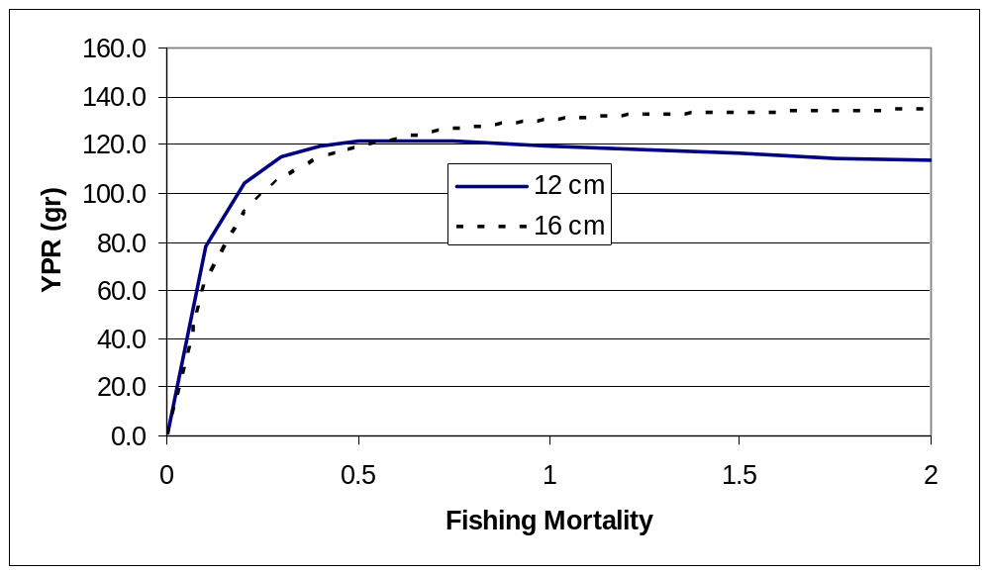

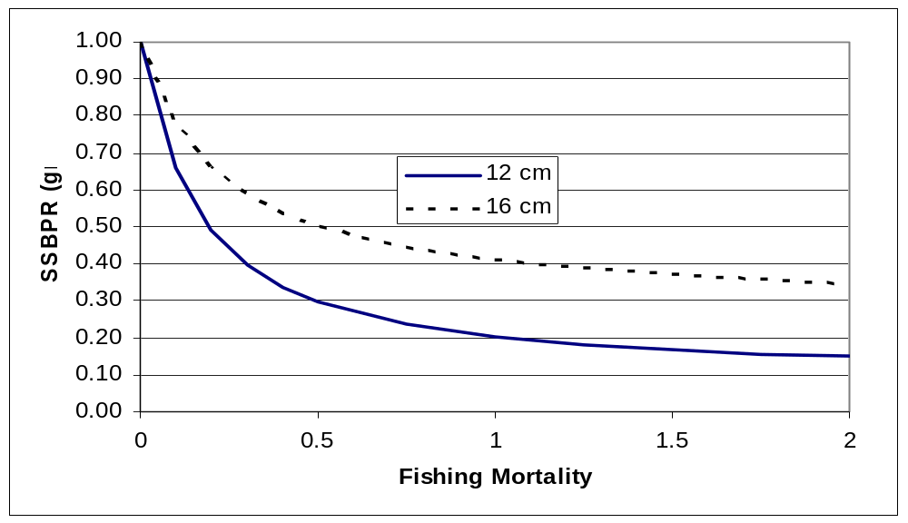

Question 5. Evaluation of status of the stock and fishing mortality

Given the results of your mortality analysis and the difference in stock status discernable in
the abundance levels of the 1985 and 1995 year classes, comment on the effectiveness of the quota regulations placed on the fishery in the early 1990s.

Answer: The regulations were effective at reducing fishing mortality by about 50%,
from 0.9 to 0.48.

Given the results of your YPR and SSBPR analyses for the current 12 cm minimum mesh size that controls age of entry into the current fishery, compare the levels of fishing mortality in the late 1980s to the levels in the late 1990s, relative to the reference points.

Answer: While the fishing mortality on the 1995 year class was reduced to less than the Fmax, the limit reference point for growth overfishing, it remains greater than the target reference point for growth overfishing of 0.25, as compared to the data for the 1985 year class. With regard to recruitment overfishing, the fishing mortality on the 1995 year class is less than the reference point, while the fishing mortality on the 1985 year class exceeds the reference point.

Finally comment on the relative merit of increasing the current 12 cm minimum mesh size to a 16 cm minimum mesh size based on YPR and SSBPR.

Answer: An increase in mesh size from 12 to 16 cm results in similar potential yield at F0.1, but in a substantially greater %SSB remaining, which will lead to faster stock rebuilding, and therefore greater catch in the future..

